

**Project report**

Java Project

Table of Contents

Introduction 3

Project presentation 3

Project actors 4

Study of the need 5

Used software 6

Provisional schedule 7

Pert diagram 7

Production 8

Project log 9

Conclusion 11

Effective schedule 11

Differences analysis 11

Encountered problems 11

Possible upgrades 11

Personal review 11

Group review 12

# Introduction

## Project presentation

For this object-oriented programing project, we were asked to realize the famous game Boulder Dash in java.

During the project, we need to use some tools like Maven, JUnit, GitHub, and a data base connector to simplify our team work. We also have to realize some diagrams like class, packages, components diagram before the coding part to modelized how the program will be executing.



## Project actors

Gautier VUILLAUME

Hugo ROUTY



Julien HENROTIN

Emmanuel BOUSSERT



The project manager (Gautier) must ensure that the schedules are set up and maintained. It also manages the division of tasks and decision-making.

## Study of the need

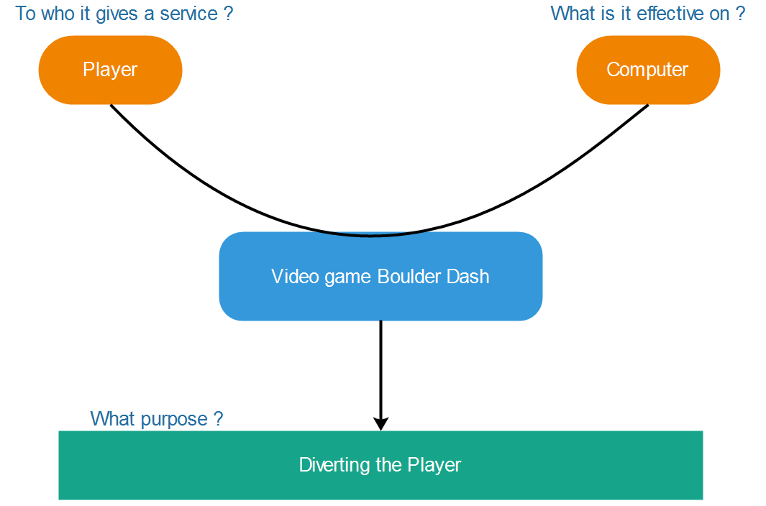Services diagram

Interactions diagram

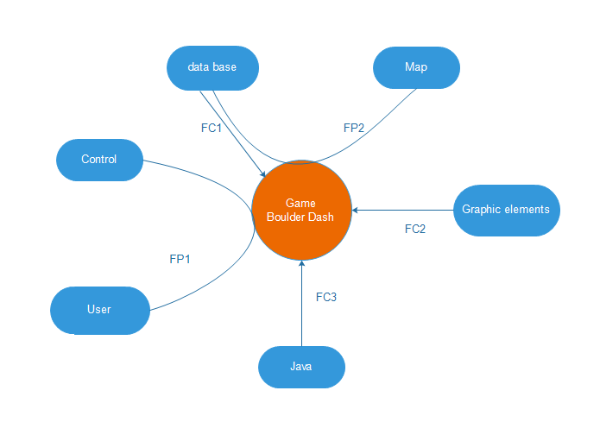

FP1: user can play to game with control on his keyboard

FP2: the map is stocked in database

FC1: The game uses the maps who is stocked in data base

FC2: The graphic elements are on an external file

FC3: The program runs under a Java environment

# Used software

|  |  |
| --- | --- |
| Afficher l'image d'origine | Office suite for the realization of deliverables and PPT. |
| Résultat de recherche d'images pour "discord" | Software to communicate easily. |
| Résultat de recherche d'images pour "gantt project logo" | Using Gantt Project to organize schedules. |
| Résultat de recherche d'images pour "wamp" Résultat de recherche d'images pour "mysql" | Using Wamp Server and the MySQL DBMS to build the database. |
| C:\Users\julie\AppData\Local\Microsoft\Windows\INetCache\Content.Word\eclipse.png | IDE use for developing our project. |
| Résultat de recherche d'images pour "jmerise logo" | Software for modeling Merise diagram (CMD…) |
| Résultat de recherche d'images pour "edraw logo" | Software for modeling class and package diagrams. |
| C:\Users\julie\Desktop\visual-paradigm.png | Software for modeling class and package diagrams. |
| C:\Users\julie\Desktop\git hub.png | GitHub is a web-based Git or version control repository and Internet hosting service. |

## Provisional schedule

We have made a Gantt diagram for represent our provisional schedule.

It is linked here:



## Pert diagram

To symbolize the tasks to be done to complete this project, we realized a pert diagram. It is linker here:



# Production

# Project log

|  |  |  |
| --- | --- | --- |
| **Date** | **Team members** | **Tasks realized** |
| 13/06/17 | BOUSSERT Emmanuel | * Subject study * Global class diagram |
| HENROTIN Julien |
| ROUTY Hugo |
| VUILLAUME Gautier |
| 14/06/17 | **Team briefing –** *Forecast of day's work* | |
| BOUSSERT Emmanuel | * Distribution of tasks * End of global class diagram * MVC class diagrams |
| HENROTIN Julien |
| ROUTY Hugo |
| VUILLAUME Gautier |
| 15/06/17 | **Team briefing –** *Forecast of day work* | |
| BOUSSERT Emmanuel |  |
| HENROTIN Julien |  |
| ROUTY Hugo |  |
| VUILLAUME Gautier |  |
| 16/06/17 | **Team briefing –** *Forecast of day and week-end work* | |
| BOUSSERT Emmanuel |  |
| HENROTIN Julien |  |
| ROUTY Hugo | * PERT Diagram |
| VUILLAUME Gautier |  |
| 17/06/17 | BOUSSERT Emmanuel |  |
| HENROTIN Julien |  |
| ROUTY Hugo | * Data base creation * Map creation |
| VUILLAUME Gautier |  |
| 18/06/17 | BOUSSERT Emmanuel |  |
| HENROTIN Julien |  |
| ROUTY Hugo | * Data base filling * Stored procedures |
| VUILLAUME Gautier |  |
| 19/06/17 | **Team briefing –** *Forecast of day's work* | |
| BOUSSERT Emmanuel |  |
| HENROTIN Julien |  |
| ROUTY Hugo | * JUnit tests * Stored procedures |
| VUILLAUME Gautier |  |
| 20/06/17 | **Team briefing –** *Forecast of day's work* | |
| BOUSSERT Emmanuel |  |
| HENROTIN Julien |  |
| ROUTY Hugo | * Implementation of the java methods that will execute the stored procedures * Class diagram update * Project Report |
| VUILLAUME Gautier |  |
| 21/06/17 | **Team briefing –** *Forecast of day's work* | |
| BOUSSERT Emmanuel |  |
| HENROTIN Julien |  |
| ROUTY Hugo |  |
| VUILLAUME Gautier |  |
| 22/06/17 | **Team briefing –** *Forecast of day's work* | |
| BOUSSERT Emmanuel |  |
| HENROTIN Julien |  |
| ROUTY Hugo |  |
| VUILLAUME Gautier |  |
| 23/06/17 | **Team briefing –** *Forecast of day and week-end work* | |
| BOUSSERT Emmanuel |  |
| HENROTIN Julien |  |
| ROUTY Hugo |  |
| VUILLAUME Gautier |  |
| 24/06/17 | BOUSSERT Emmanuel | * *Production of the slideshow* * *Oral preparation* |
| HENROTIN Julien |
| ROUTY Hugo |
| VUILLAUME Gautier |
| 25/06/17 | BOUSSERT Emmanuel | * *Production of the slideshow* * *Oral preparation* |
| HENROTIN Julien |
| ROUTY Hugo |
| VUILLAUME Gautier |
| 26/06/17 | BOUSSERT Emmanuel | * *Last update on the presentation* * **PRESENTATION** |
| HENROTIN Julien |
| ROUTY Hugo |
| VUILLAUME Gautier |

# Conclusion

## Effective schedule

## Differences analysis

## Encountered problems

## Possible upgrades

## Personal review

* Emmanuel BOUSSERT:
* Julien HENROTIN:

Thanks to this project I could participate to design of the complete design of an entire program.

* Hugo ROUTY:
* Gautier VUILLAUME:

## Group review